Part 1

Help Text-Faculty (Part 1)  
**Credentials-**Please list the highest credential related to the position the instructor is teaching. For example, if an instructor holds a Bachelor’s in Mechanical Engineering and a Master’s in Religion and they are teaching in Mechanical Engineering, please put the Mechanical Engineering degree down because that is the degree relevant to the position.

**Date-**This is the date the credentials were awarded. Please put the date in the following format MM/DD/YYYY

**Institution-**The college/university which awarded the credentials

**Course-**These are the courses in which the instructor teaches related to the credential identified for the program you are completed the five year program review.

**Affiliations-**These are professional memberships, etc. which are related to the program in which they are an instructor.

**Start Date-**This is the date in which the instructor began teaching in the program being reviewed. Please put the date in the following format MM/DD/YYYY.

**End Date-**This is the date in which the instructor stopped teaching in the program being reviewed. If they are still teaching in the program, please leave blank. Please put the date in the following format MM/DD/YYYY.

**Workload-**Total sections taught each year and the total number of students taught each year.

**Commitments-**Advisees, committees, special projects, and other work-related items the instructor has participated in outside of the classroom.

**Attachments**-Please upload any documentation to support information presented if it is not currently on file in the curriculum office.

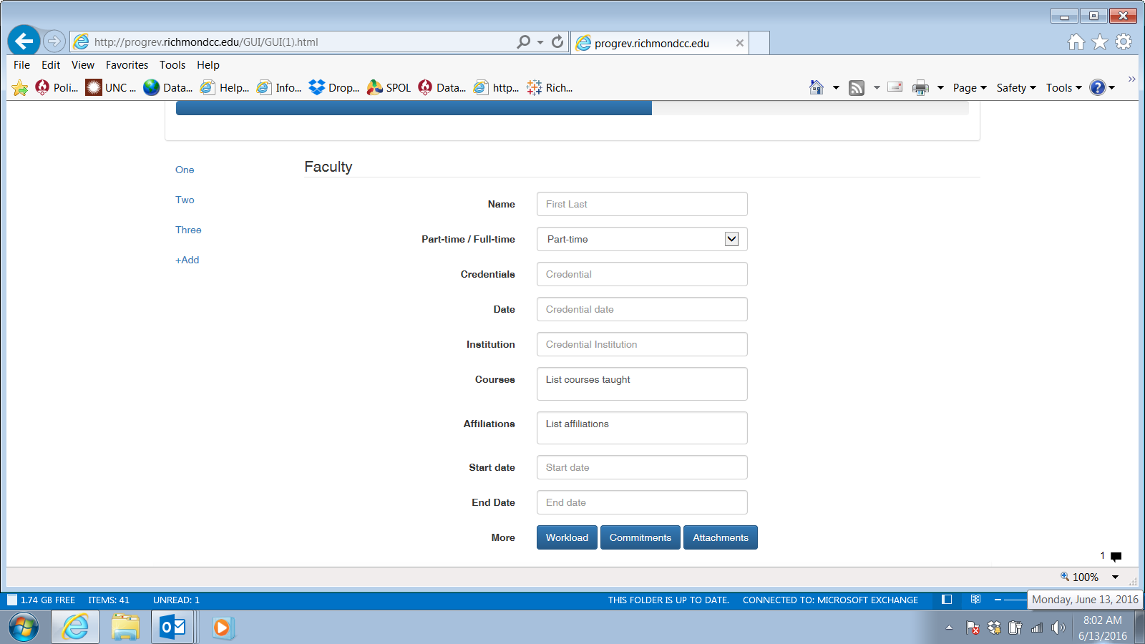

Part 2

**Catalog Description-** Please verify that the description in the course catalog for the program you are reviewing is accurate. If not, please identify the corrections below in the “Corrections” box.

**Objectives and Outcomes-**If you are an AAS program, what are the Program Learning Outcomes you would measure every graduate of your program. If you are an AA/AS/AE program these may be your student learning outcomes for your program and general education.

**Program to Course Matrix-**Please identify the sequence of courses for each program learning objective is introduced, emphasized, reinforced, and then assessed in your program of study. The assessment measures should be part of the program’s SPOL assessment.

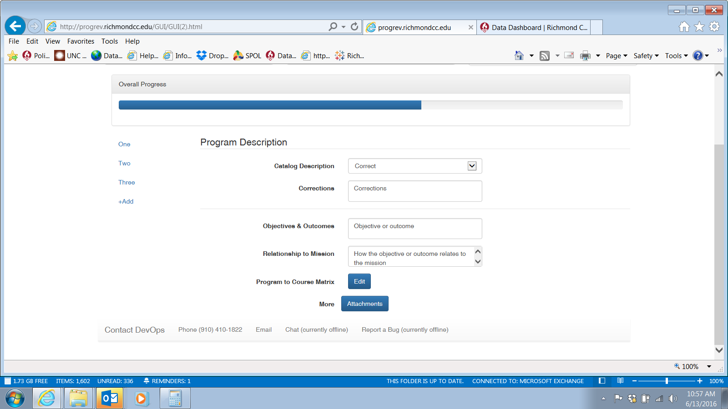

Part 3

**Course Numbers-** The course numbers identified as the assessment of the program learning outcome will show here and along the side to the left.

**Performance Measures-** For each of the last five years, please document the actual assessment results for the assessed course.

**Summary-**Write a brief summary of the assessment findings across the last five years.

**Problems-**Identify areas which were more difficult for students to complete or they had more trouble. How do you plan to address these areas?

**Effectiveness-**Are these assessment measures still the most effective for the program? Please explain.

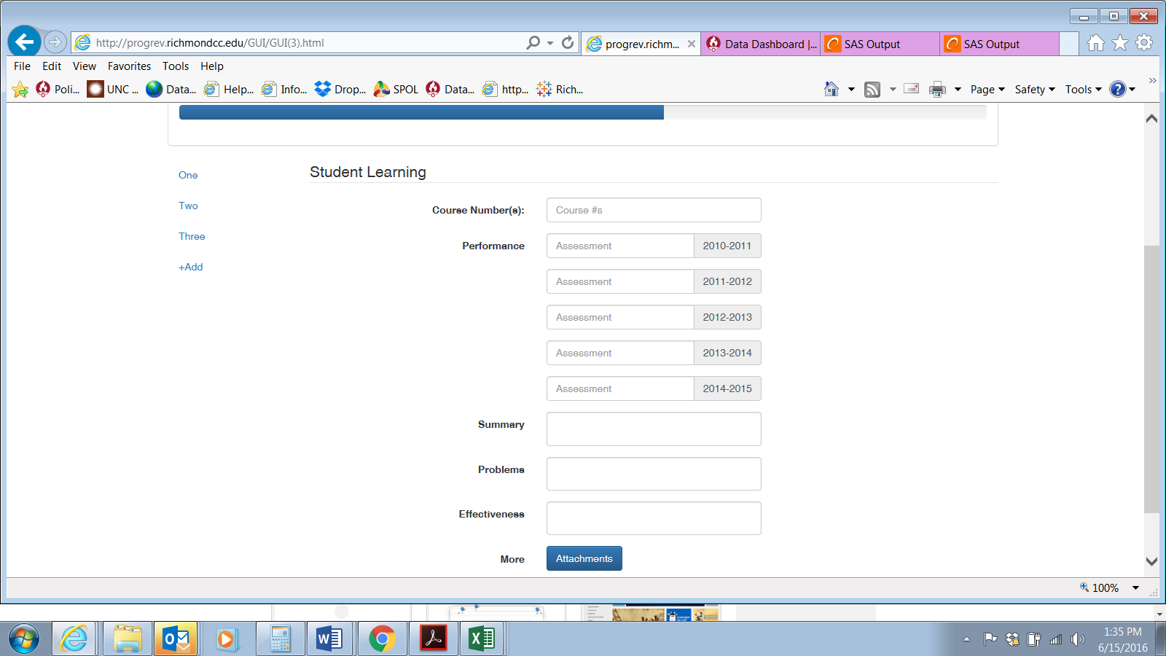

Part 4

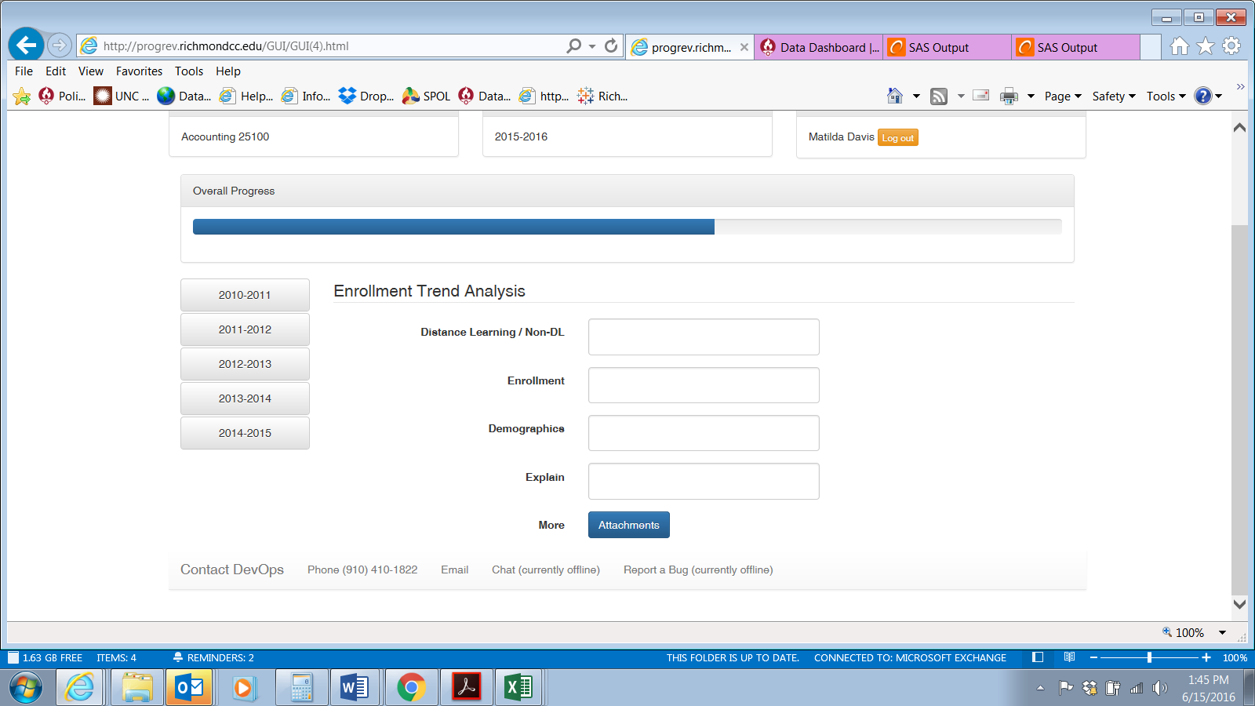

**Distance Learning/Non-DL-** Looking at the data tables for the five years, please summarize the distance learning/non-dl participation for students in your program.

**Enrollment-**Looking at the data tables for the five years, please summarize the enrollment trends. This would include totals, load, employment status, credentials enrolled, and student residence.

**Demographics-**Looking at the data tables for the five years, please summarize the demographic trends. This would include gender, age, and ethnicity.

**Explain-**Please identify any significant findings and items which need to be addressed in relations to enrollment and demographics over the next five years.

Part 5

In order to complete this section you will need to go to [www.nctower.com](http://www.nctower.com)   
**NC TOWER** (North Carolina's Tool for Online Workforce and Education Reporting), a product of the Common Follow-up System. Select "Community Colleges" or "Public Universities" from the right and click "Go" to view information about the workforce and educational outcomes of programs at those institutions. Or, scroll down on this page to see selected statistics about North Carolina's State-funded education programs.

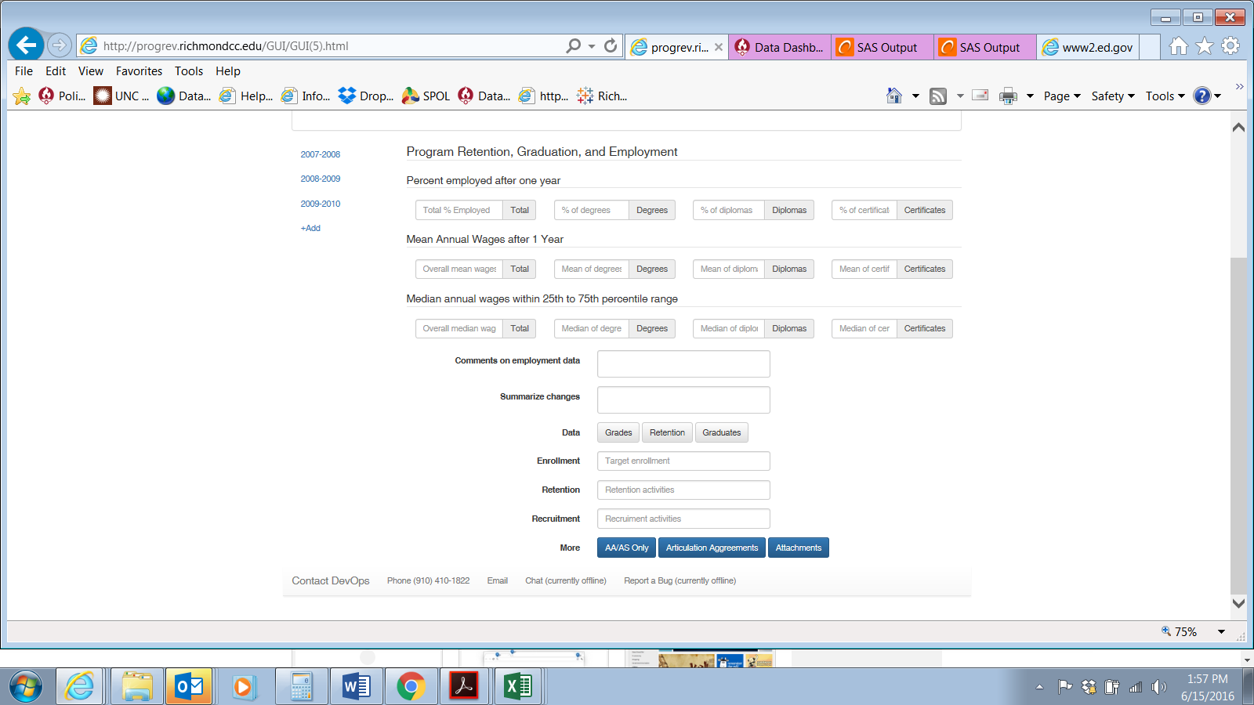

Percent Employed After One Year- This is for the highest credential your program offers.

Step 1- Select Community College in this box and click on GO.

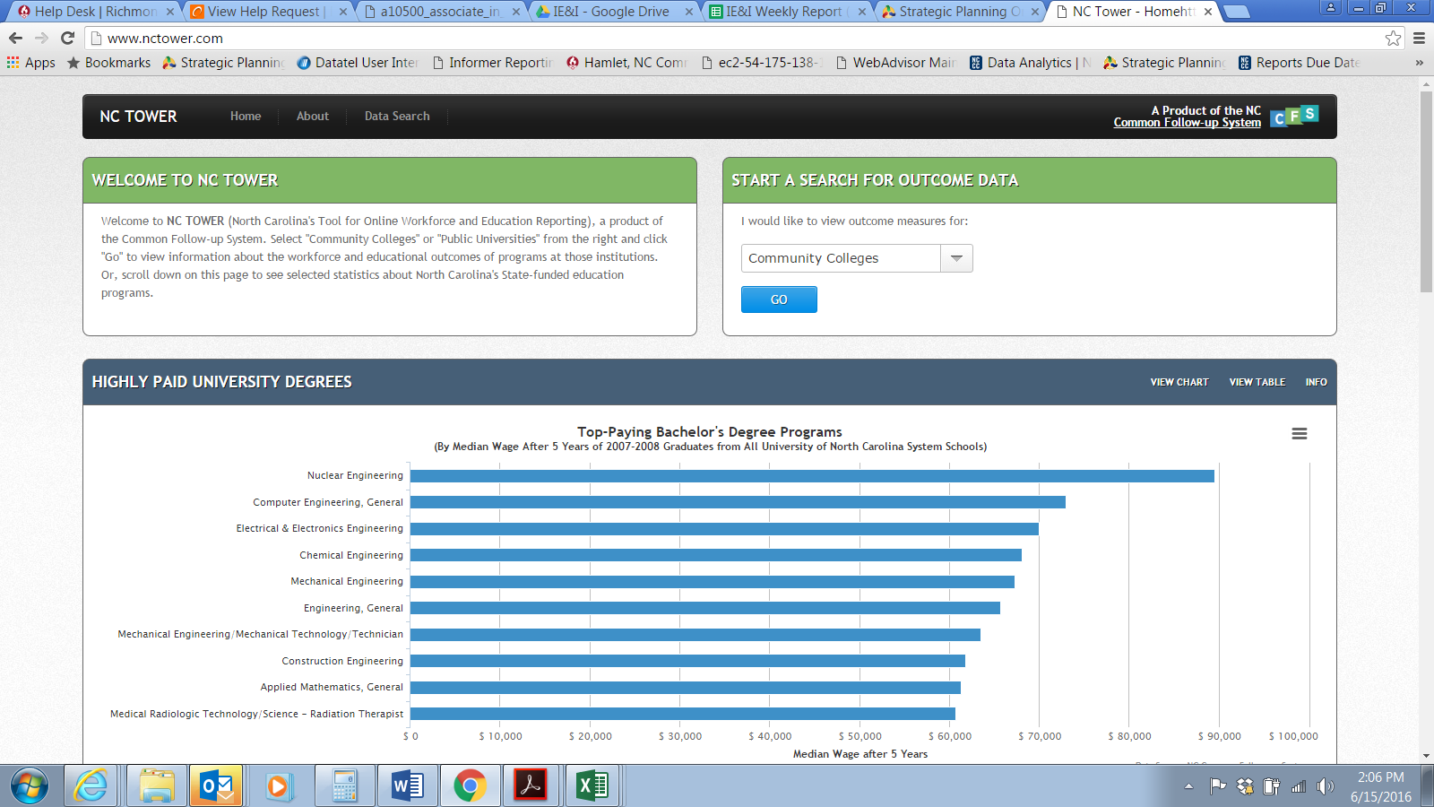

Step 2- Select the highest credential, Richmond Community College, and type in your program of study (subject area) in the provided boxes. The click the green plus sign next to your program.

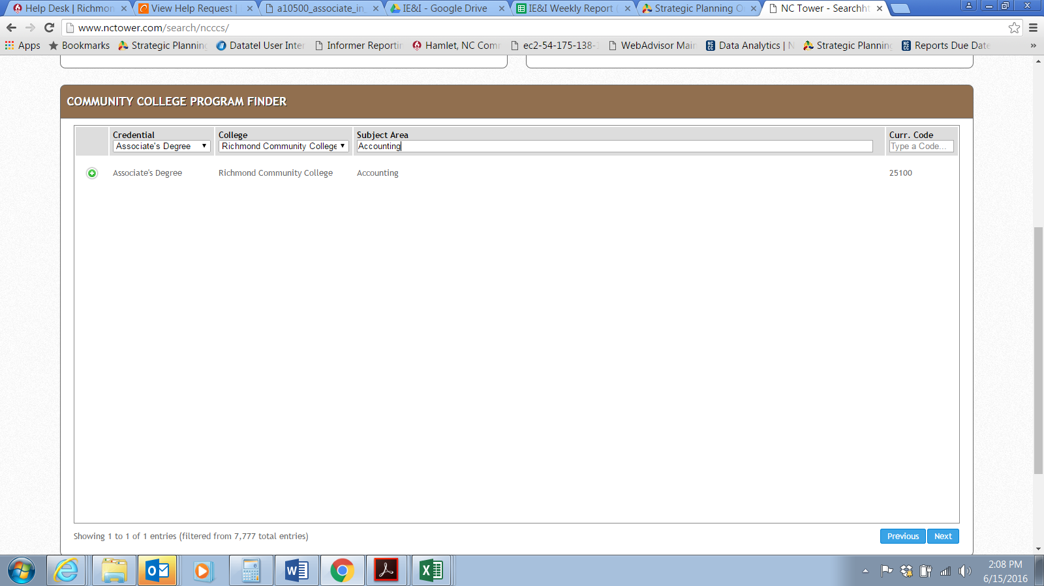

Step 3-Click on View Outcomes in the upper left hand box on the webpage.

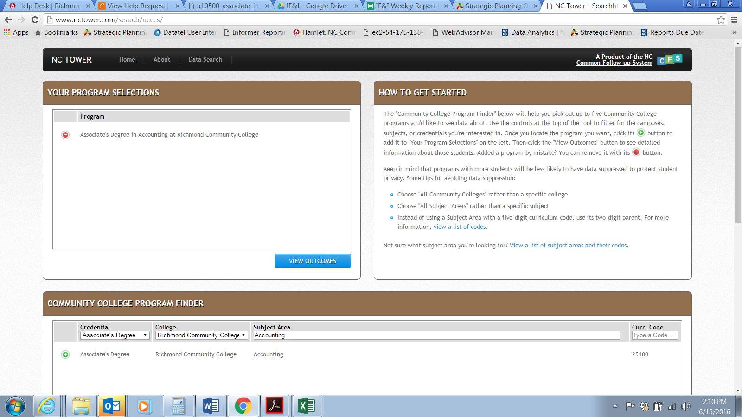

Step 4-Change the year to examine each of the components required for each of the requested years. If there is not sufficient data, please type in “outcome data suppressed by NCTower”.

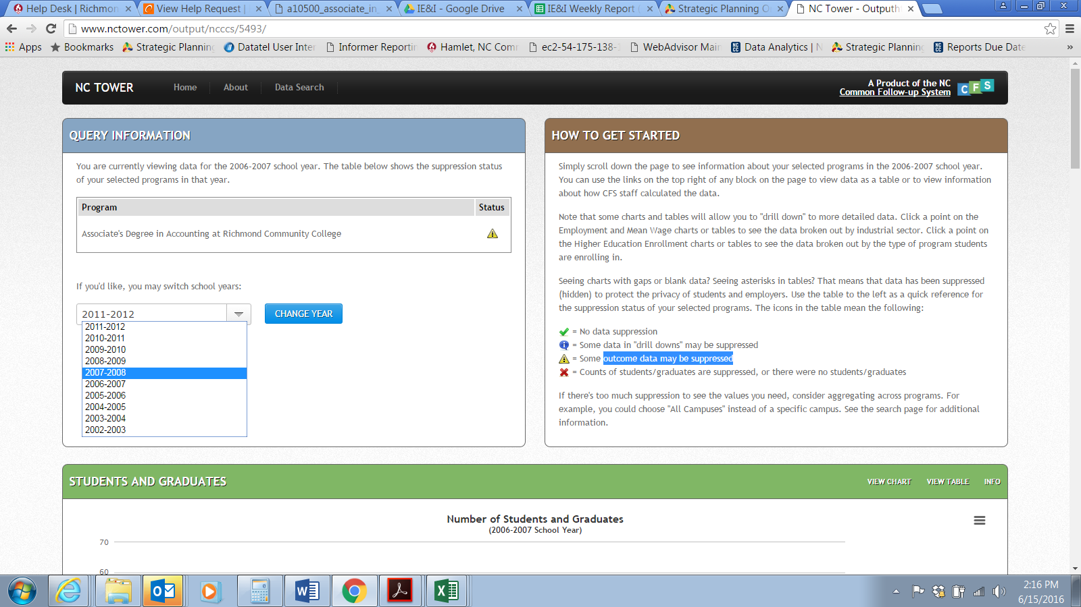

Part 6

Plan- These are items/supports you plan on incorporating over the next five years. Your choices are:

* Facilities-These are any items you need to purchase or changes which need to be made to offices, classrooms, equipment, etc.
* IT-These are any software items you will need to support your program.
* Personnel-These are any new instructors/staff you feel need to be added to your program in order to meet student need and/or growing demand.
* Program/Curriculum-These are changes and/or additions to your current program such as new courses, new credentials, new concentrations, etc.

Change- Please describe what the specific change are that you have identified.

Links-Please put a link to the items you are wanting to purchase.

Strengths-Of your program

Opportunities-Areas for improvement these new plans will assist.

